**A friendly Norwegian invasion**

by [admin](http://www.na-weekly.com/author/admin/) · March 13, 2015

**The world’s longest-running troop exchange brings Norwegians and Minnesotans together**

[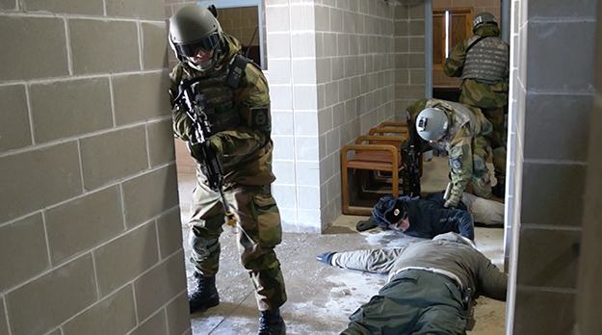](http://www.na-weekly.com/wp-content/uploads/2015/03/Norwegians-with-two-prisoners-role-played-by-Minnesota-Guardsmen-Screenshot-2015-03-03-13.56.04.jpg)

Photo: Aaron Hagström  
Norwegians with two prisoners, played by Minnesota Guardsmen.

Aaron Hagström  
North Oaks, Minn.

Four soldiers stood over two prone captives in the atrium of a concrete building, shouting in Norwegian and exhaling clouds of cold vapor, as Investigator Jason McDonald of Minnesota’s Morrison County Sheriff’s Department instructed them what to do next. “Secure them; search them; ask them for intelligence; call the squad cars to pick them up,” he coached.

This was one scene from the culminating military exercise in the 42nd annual American-Norwegian Reciprocal Troop Exchange (NOREX) that ended Feb. 22; Norwegian soldiers spent a busy two weeks at Camp Ripley, Minnesota; and U.S. Army Minnesota National guardsmen spent the same period in Norway.

What began as a handshake—when heads of the Norwegian Home Guard (HV or RRF) and Minnesota National Guard (MNG) met at Camp Ripley in 1973—became the longest such military exchange between any two nations. Only in the 1990s was it formalized with official documentation.

Once every year at Camp Ripley, the RRF conducts military exercises and the Norwegian Home Guard’s Youth (HVU) learn weapons and survival skills. This year 56 RRF, one Danish officer, and 38 youth participated, supported by 96 National Guardsmen.

Meanwhile, the Minnesota National Guard travels to Norway; this year, they celebrated the 70th anniversary of Operation RYPE, a 1945 ski-parachute operation in which Norwegian-American soldiers (many from Minnesota and the Dakotas) successfully assisted in sabotaging German rail lines and bridges in Norway. One hundred guardsmen participated.

NOREX is only one of the 13,000-strong Minnesota National Guard’s international cooperatives. Since 1994 the MNG has conducted exchanges with Croatia as part of the Partnership for Peace program, and it also has an exchange with the UK. The National Guard has deployed soldiers and airmen to more than 33 countries since 2001, including Kosovo, Croatia, Egypt, and Kuwait.

[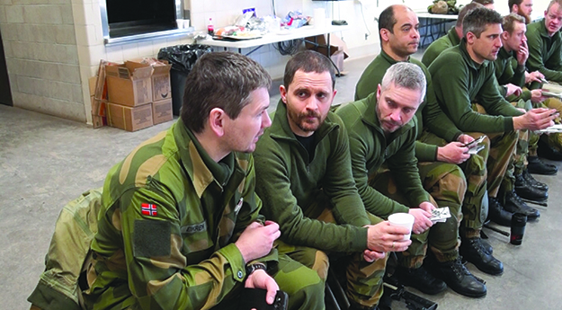](http://www.na-weekly.com/wp-content/uploads/2015/03/Lt.-Eric-Nagel-waits-to-get-briefed-2015-03-03-14.28.26-copy.jpg)

Photo: Aaron Hagström  
Lt. Eric Nagel (second from left) and other Norwegians wait for the briefing to begin.

The program is meant to build friendship through the mutual sharing of military competence and cultural experience. Norwegians at Camp Ripley experience various aspects of Minnesota culture. They attend a Minnesota Wild hockey game, visit the Twin Cities to shop at the Mall of America, and go to an American fish fry at the local VFW. The Minnesota exercises, for the last two years, have aimed at military and police cooperation, rather than at the traditional preparation for wartime winter operations. Since 9/11, there has been more combined training initiatives between the National Guard and emergency response personnel, in preparation for natural disasters, border issues, active shooters, and hostage situations. That kind of training is also relevant for Norwegians, who experienced a lone-wolf terrorist attack in 2011 that killed 77 people, as police struggled to respond in time and without the assistance of the recently disbanded anti-terrorist home guard unit.

Training during the first week includes familiarization with various weapons, and the second week includes a gradual three-day lead up to a culminating exercise. This exercise has what the U.S. military calls crawl, walk, and run phases. On the first two days, the RRF learn about police weapons, sniping, room clearing, and hostage negotiations. The third day, they walk through the operation. On the day of the exercise, they assault the fictional city of Qwamba (i.e. the urban training center called the Combined Arms Collective Training Facility or CACTAC). When Qwamba is purportedly taken over by eco-terrorists who are protesting the building industrial complex, and the city denies the terrorists’ request to protest, the situation escalates into a violent scenario of gunmen, snipers, bombs, and hostages. The Norwegians must work with local police to restore peace and security. Minnesota guardsmen facilitate the exercise by role-playing terrorists, hostages, and unarmed civilians. The Norwegians receive daily intelligence briefings about fictional events occurring in and around Qwamba, and even conduct aerial reconnaissance by flying over the CACTAC.

[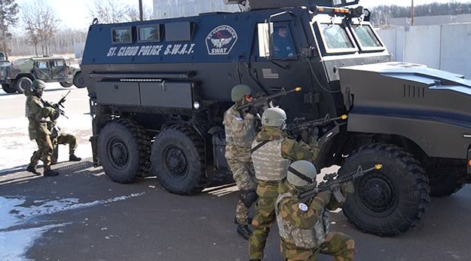](http://www.na-weekly.com/wp-content/uploads/2015/03/Norwegians-looking-for-snipers-2015-02-25-19.10.09.jpg)

Photo: Aaron Hagström  
Norwegians look for snipers, using a St. Cloud Police S.W.A.T. vehicle for cover.

On the morning of the exercise this year, everyone gathered around a makeshift panorama made of tissue paper and cardboard, as exercise commander Lt. Col Bryce Erickson of the National Guard briefed police and Norwegians, and ordered them to secure Qwamba. The Norwegians moved out toward the urban training site, in a column including 25 Humvees, two Mine-Resistant Ambush Protected SWAT vehicles (used by U.S. military units in Afghanistan), and police and National Guard ambulances. They ran into a protest in front of the concrete government building. Norwegian and police snipers set up, as police, sheriff, and SWAT officers led six- to nine-man groups of Norwegians into the building. They methodically cleared rooms of terrorists, while communicating with each other by radio; in one place, a robot searched ahead of them. Heavy metal rock music blared from wall speakers. Second Lt. Ostenby, of the RRF, said he found the SWAT tactics more aggressive and spontaneous than he was used to practicing in the Home Guard.

Maj. Gen. Tor Rune Raabye, commanding general of the Home Guard, said his soldiers were sharper this year, partly because of a more select application process back home and a favorable training experience with the MNG. As far as the operation, he said the mutual understanding that comes of the exchange has proven valuable in Afghanistan, where he knows of former participants who recognized each other. Although the techniques, tactics, and procedures are relatively the same between the two organizations, he said it is the little details that make the difference between life and death. He enjoys working with Minnesotans because they remind him of the typical Norwegian.

“They are friendly, enthusiastic, engaged in what they are doing; they like cold, and appreciate their elbowroom,” Raabye said.

[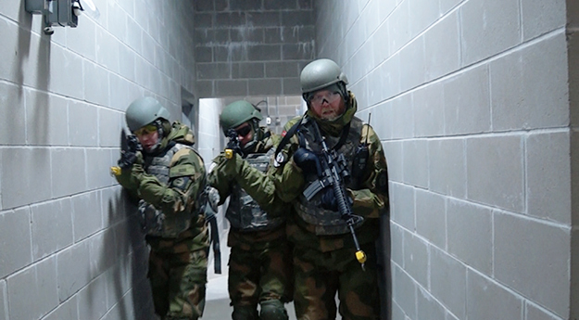](http://www.na-weekly.com/wp-content/uploads/2015/03/Norwegians-clearing-government-building-of-terrorists-2015-03-03-14.18.48-copy1.jpg)

Photo: Aaron Hagström  
Norwegian soldiers clear a building of terrorists.

However, he said one of the biggest challenges for Norwegians this year was the cold: Norway’s cold is humid, as opposed to the dry cold of Minnesota. On the day of the operation, the temperature was -12F.

Raabye and Maj. Gen. Finn Hanne­stad, Norwegian defense attaché to the Royal Norwegian Embassy, stayed at Valhalla, a Norwegian-style log chalet built in 1934 for visiting generals and Minnesota governors. Gov. Elmer Anderson, in 1961, named it “Valhalla” after the great hall of Odin in Norse mythology. The name was chosen since Minnesota has a rich Nordic heritage, with more Norwegian-Americans than any other state. Ever since 1974, the Norwegians have bestowed the National Guard with presents that are often kept in the lodge. These include a portrait of the King and Queen of Norway, cross-country skis, rosemaling, and other objects cherished in Norwegian culture. This year it was a print of a 15th century painting of the original Norwegian seaport of Bergen. The National Guard presented two custom-made Minnesota Wild hockey jerseys to Raabye and to Lt. Col Ingvar Seland, Norwegian senior training coordinator.

“Imagine, you are that far away from home, and you come to a place that is named after something you hold very dear in your heart, as far as Norse mythology,” said John Donovan, a Camp Ripley public affairs officer. “They thought it was cool, and ever since they have brought a gift.”

At the closing ceremonial dinner, Norwegian and American dignitaries offered toasts to the Home Guard and National Guard, and gave speeches celebrating the long-lasting relationship between Norway and Minnesota.

“The developments in Crimea and Ukraine have proved we are living in a world where it is hard to predict what will happen,” Hannestad said. “The answer is to keep on building allies and friendships, and that is exactly what we are doing at Camp Ripley today.”

*Look for part two of this report from NOREX in an upcoming issue, when Aaron Hagström will focus on the younger Norwegians’ experience of Minnesota.*

*This article originally appeared in the March 13, 2015, issue of the Norwegian American Weekly. To subscribe, visit* [***SUBSCRIBE***](http://www.na-weekly.com/subscribe/) *or call us at (206) 784-4617.*